ADF ASSIGNMENT
1.What is Data Profiling and how it is done?
Data profiling means understanding the data before using it.
We check:
- What columns are present
- Data types (string, number, date)
- Missing values
- Duplicate records
- Incorrect or inconsistent formats
It is done using:
- printSchema() to check structure
- display() to view data
- Checking nulls, duplicates

1) Create a container in ADLS with the project name as sales_view_devtst
- Create a folder for customer, product, store, and sales - Upload the files in sequence to make it work in real-time.
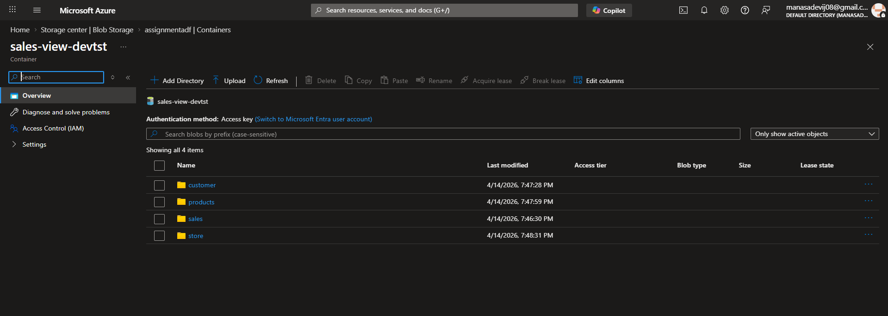
2) Create an ADF Pipeline to get the latest modified files the folders of the ADLS
- Parameterize the Pipeline to work dynamically.
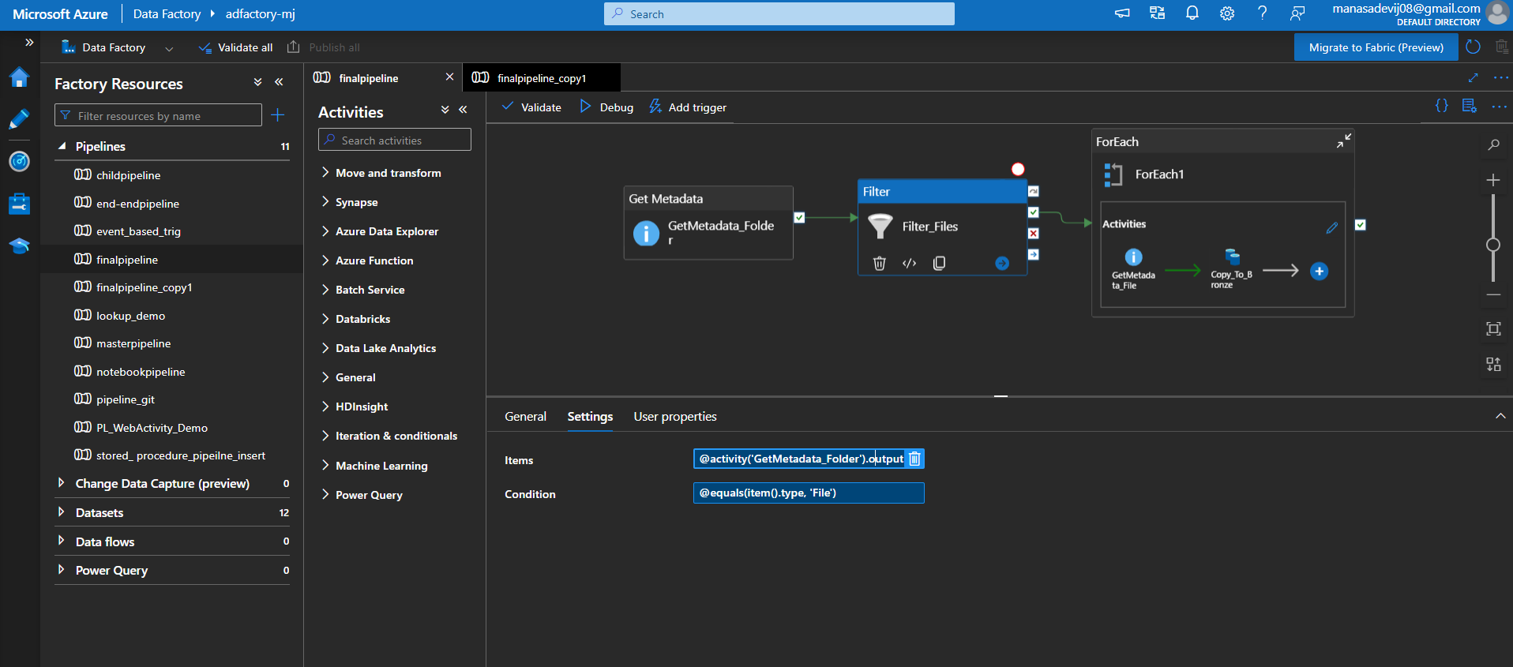
- Values need to be passed through parameters and it should work for all day's file
- Get Metadata Activity
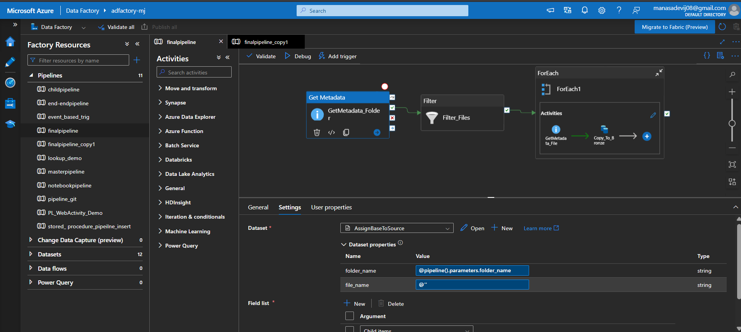
- Pipeline parameters
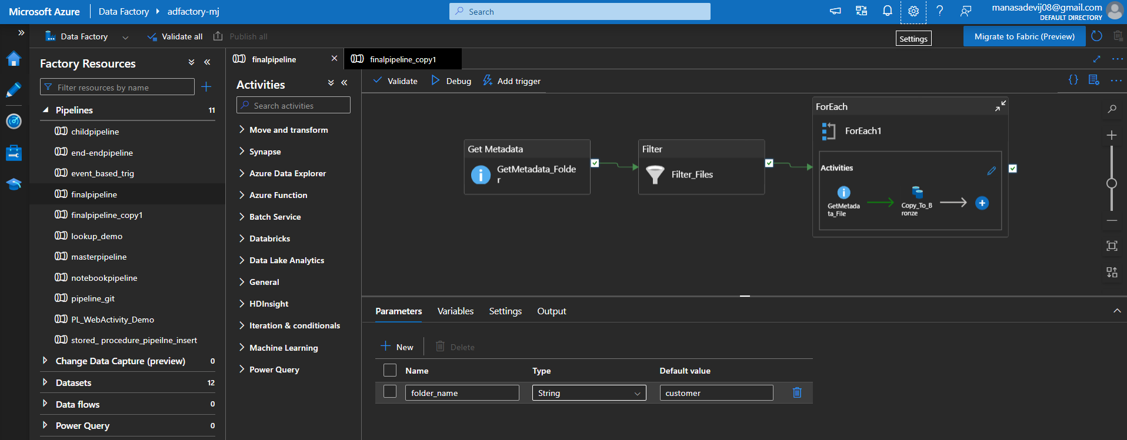
- Filter Activity
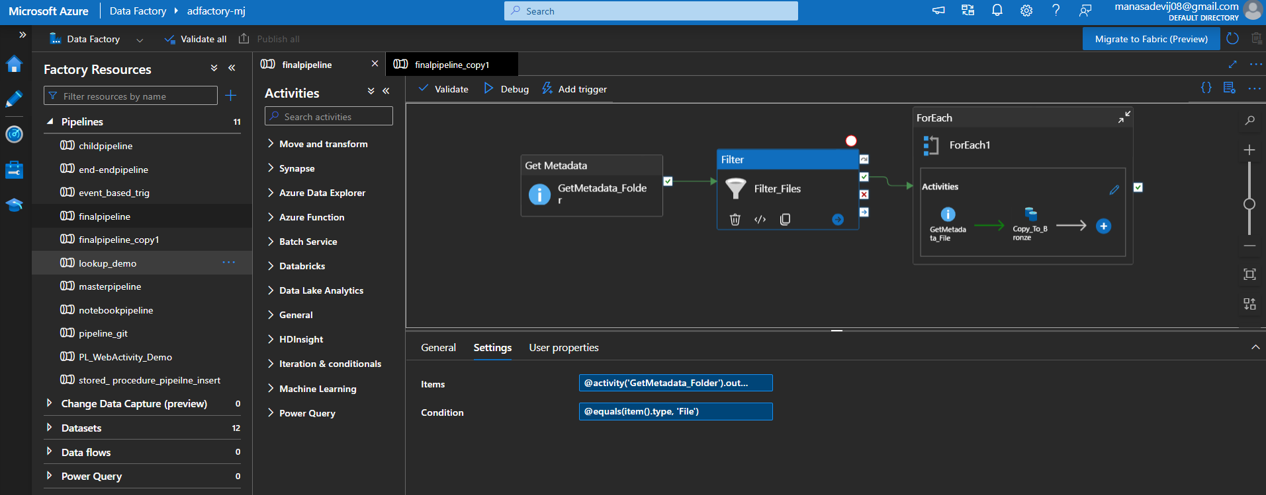
3) Create a Bronze/sales_view/ (Bronze – container)
- Subfolders-> customer, product, store, sales, and store the raw data copied from the ADF pipeline
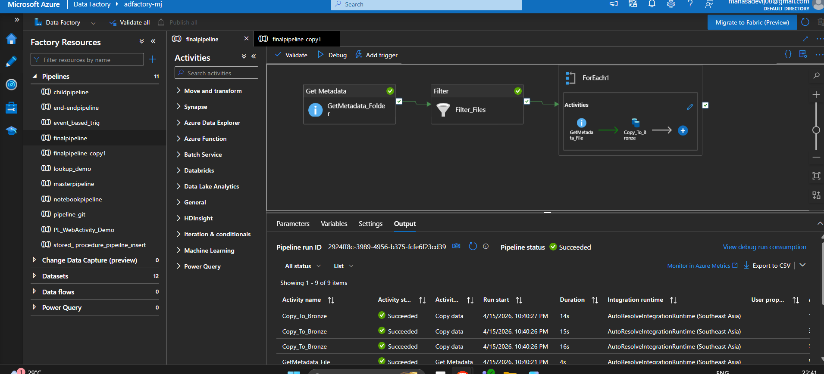
Database name: sales_view
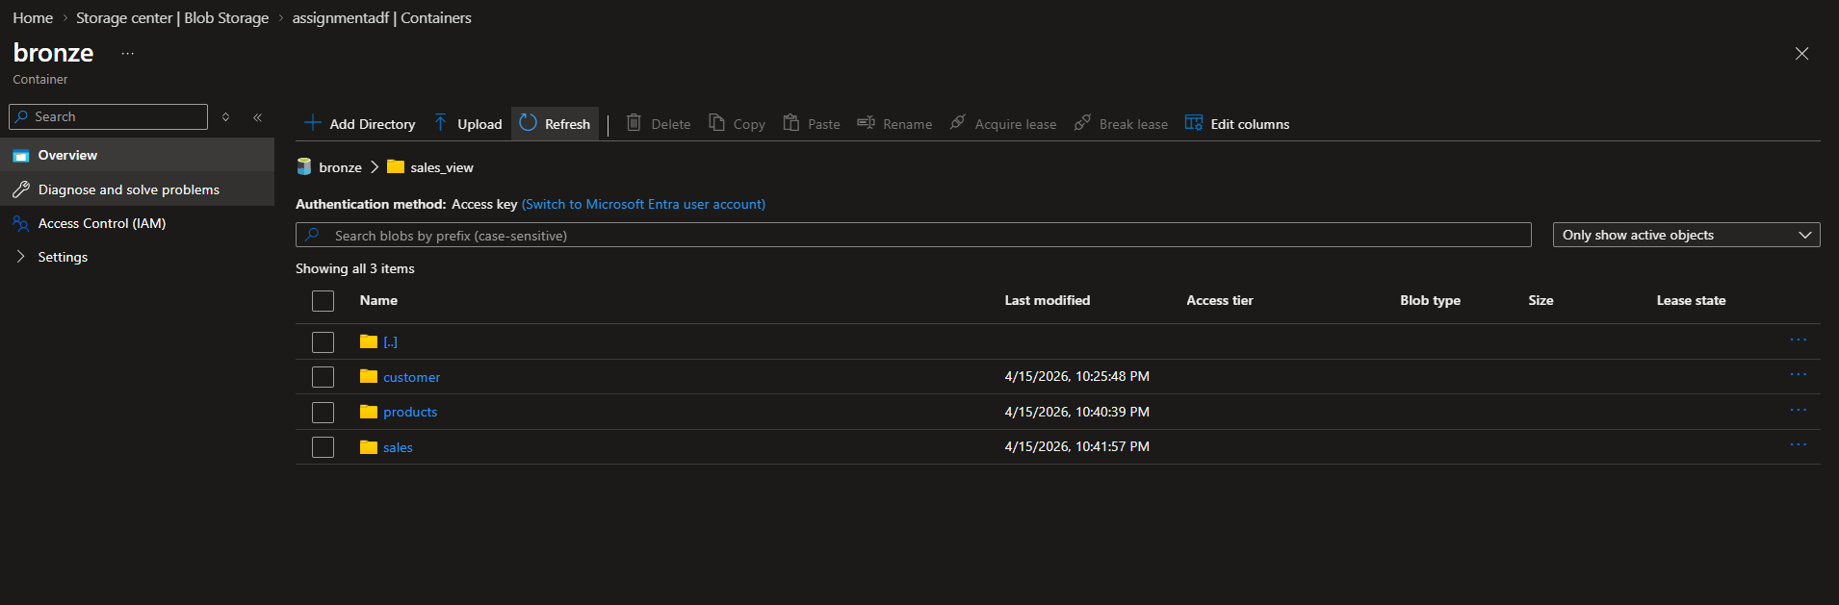
5) Customer file
- All the column header should be in snake case in lower case (By using UDF function dynamically works for all camel case to snake case)
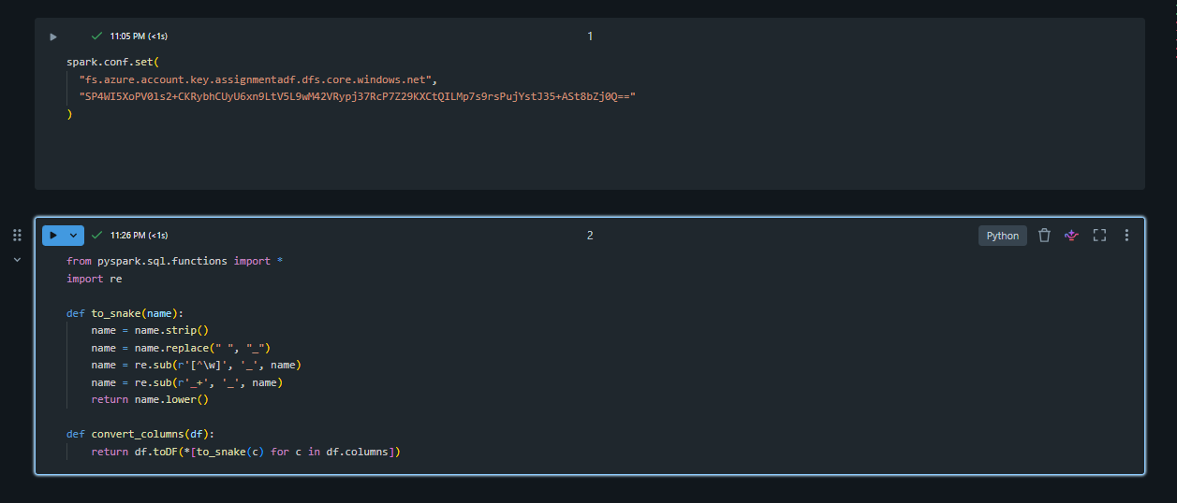
- By using the "Name" column split by " " and create two columns first_name and last_name
- Create column domain and extract from email columns Ex: Email = "josephrice131@slingacademy.com" domain="slingacademy"
- Create a column ‘gender where male = "M" and Female="F"
- From Joining date create two colums date and time by splitting based on " " delimiter.
- Date column should be on "yyyy-MM-dd" format.
- Create a column expenditure-status, based on spent column is spent below 200 column value is "MINIMUM" else "MAXIMUM"
- Write based on upsert [table_name: customer] (in silver layer path is silver/sales_view/tablename/{delta pearquet}
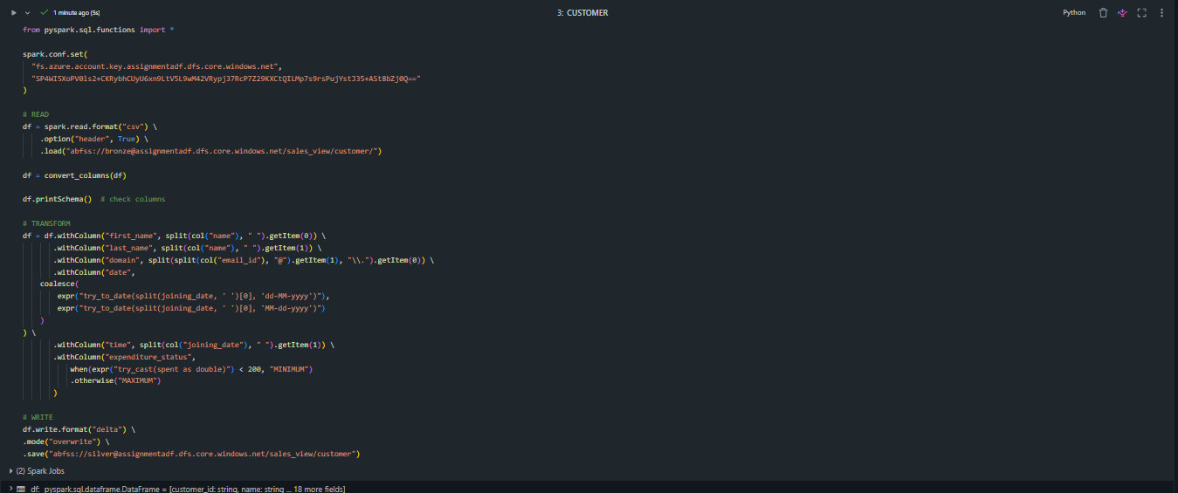
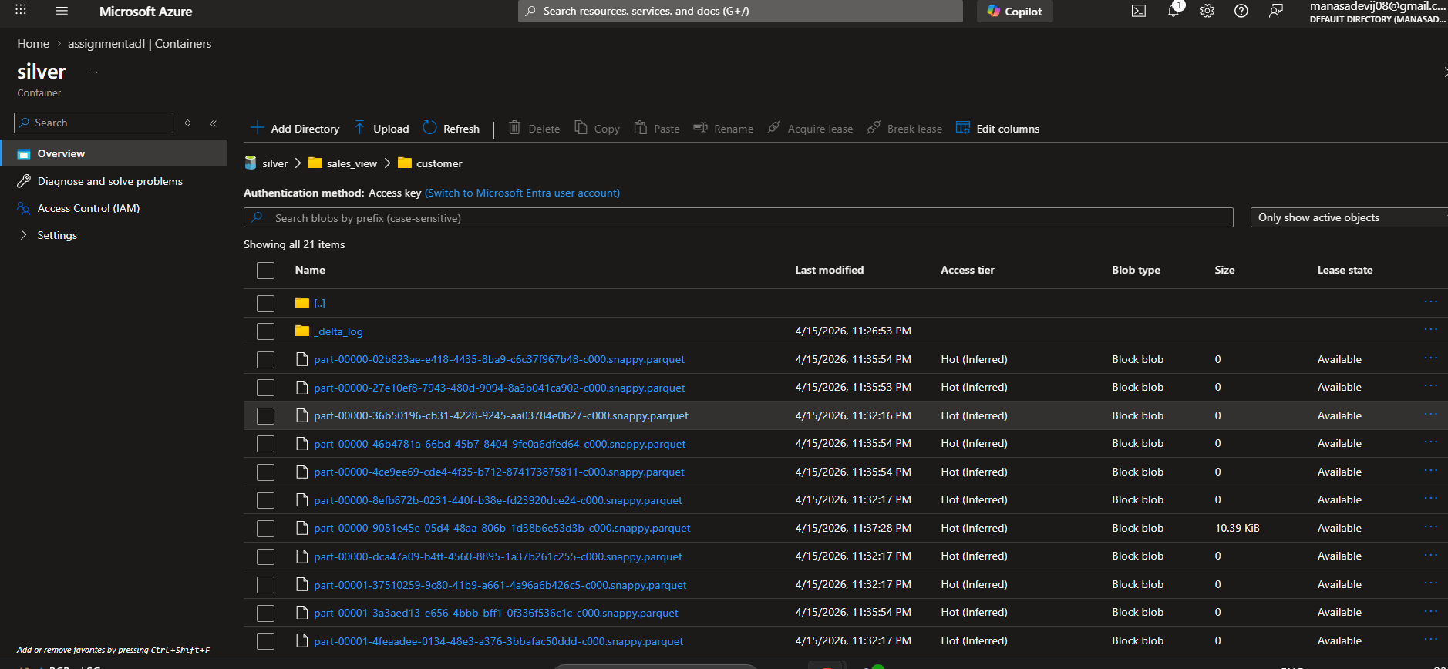
6) Product File
- All the column header shlould be in snake case in lower case (use same UDF Function)
- Create a column sub_category (Use Category columns id category_id=1, "phone"; 2, "laptop"; 3,"playstation"; 4,"e-device"
- Write based on upsert [table_name: product](in silver layer path is silver/sales_view/tablename/{delta pearquet}
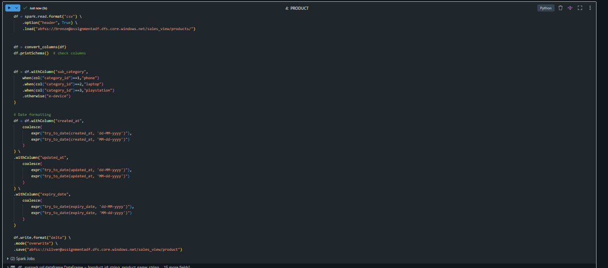
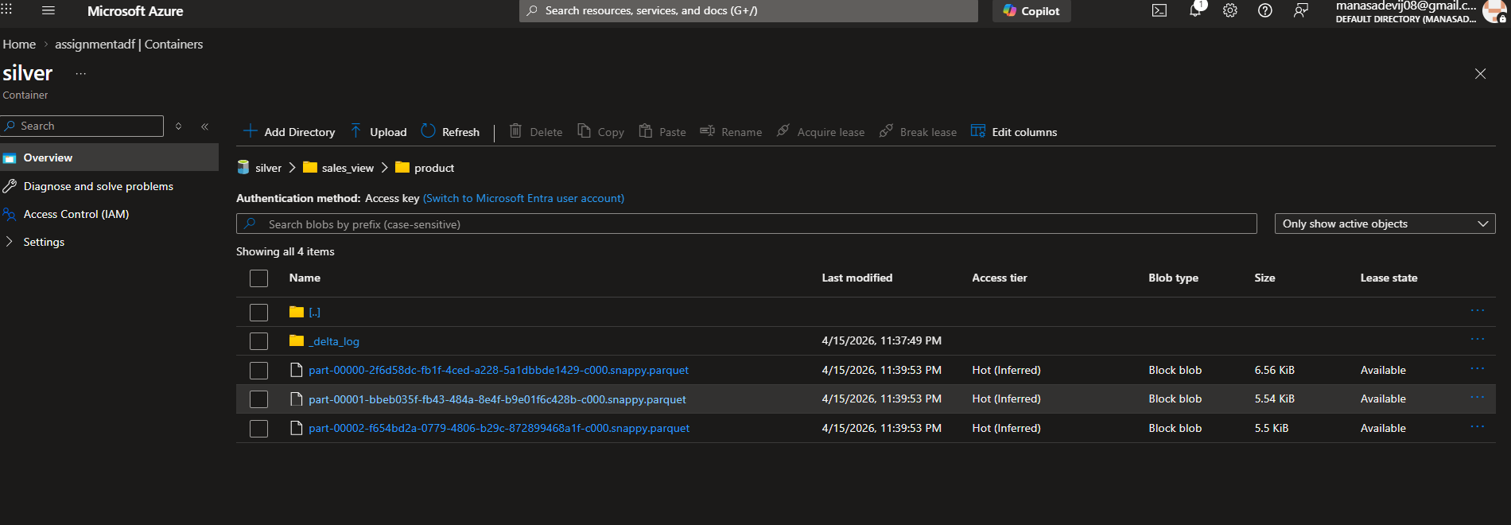
7) Store
- Read the data make sure header shlould be in snake case in lower case (use same UDF Function)
- Create a store category columns and the value is exatracted from email Eg: "electromart" from johndoe@electromart.com
- created_at, updated_at date as yyyy-MM-dd format
- Write based on upsert [table_name: store] (in silver layer path is silver/sales_view/tablename/{delta pearquet}
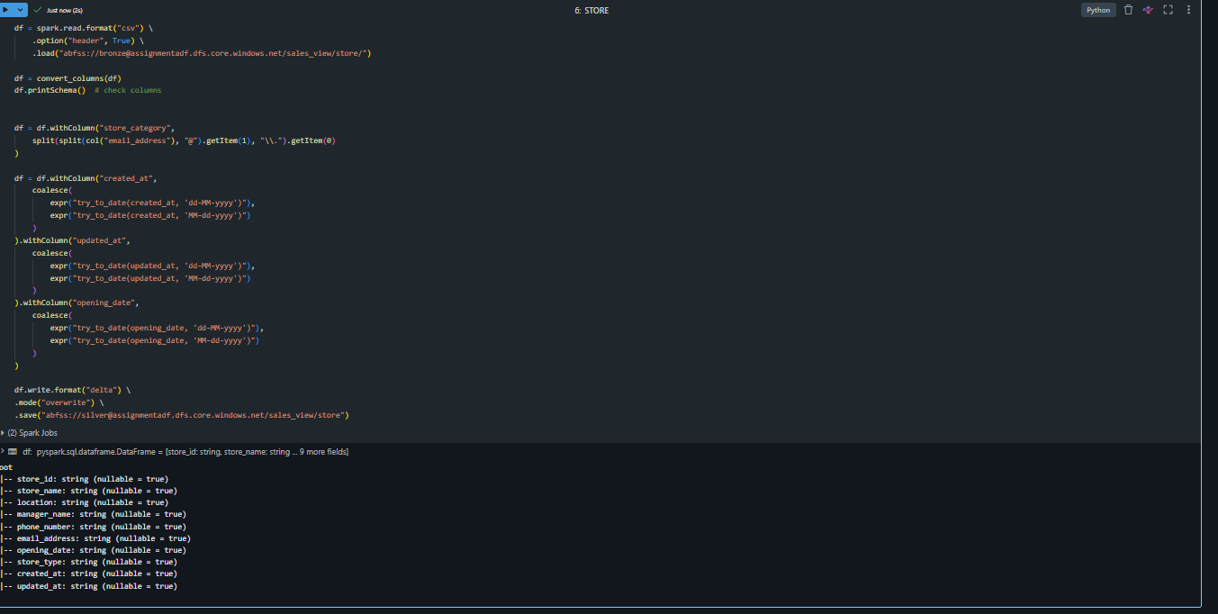
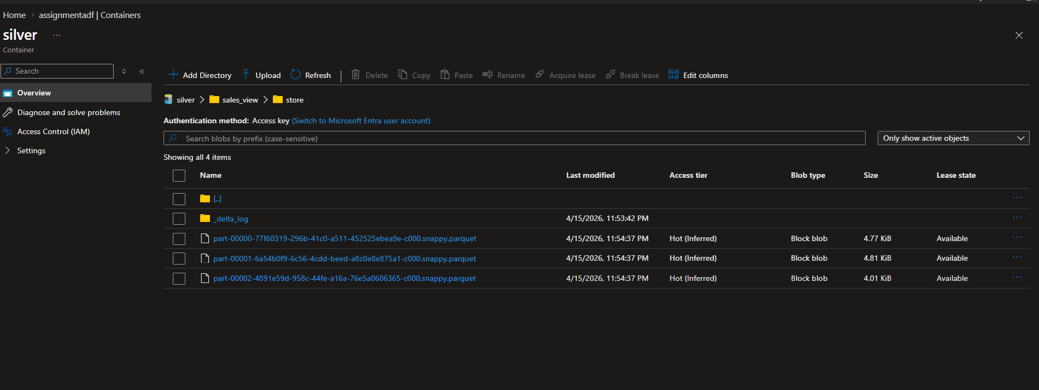
8) Sales
- Read the data make sure header shlould be in snake case in lower case (use same UDF Function)
- Write based on upsert [table_name: customer_sales] (in silver layer path is silver/sales_view/tablename/{delta pearquet}
Note: all date needs to be manintained in yyyy-MM-dd format only

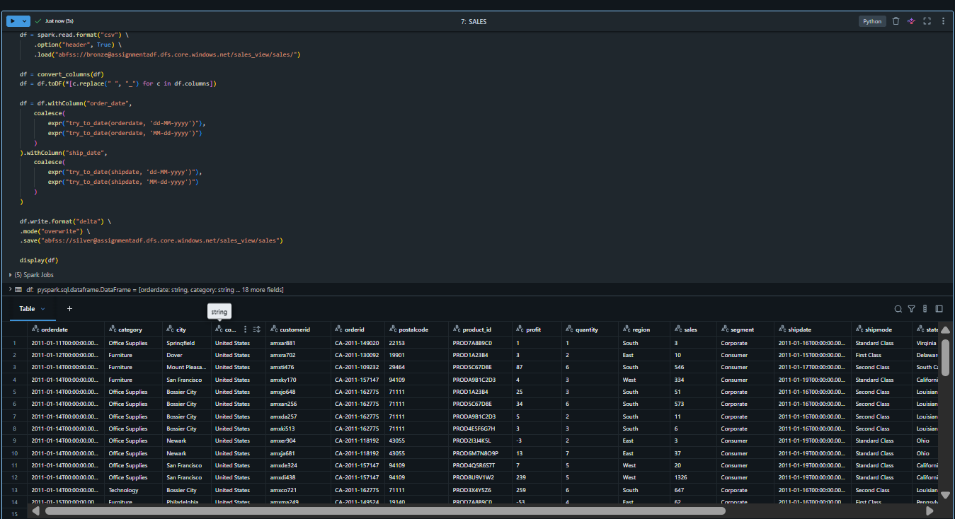
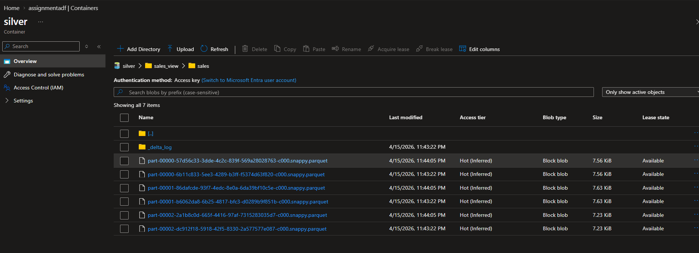
8) In gold layer
- using product and store table get the below data
store_id,store_name,location,manager_name,product_name,product_code,description,category_id,price,stock_quantity,supplier_id,product_created_at,product_updated_at,image_url,weight,expiry_date,is_active,tax_rate.
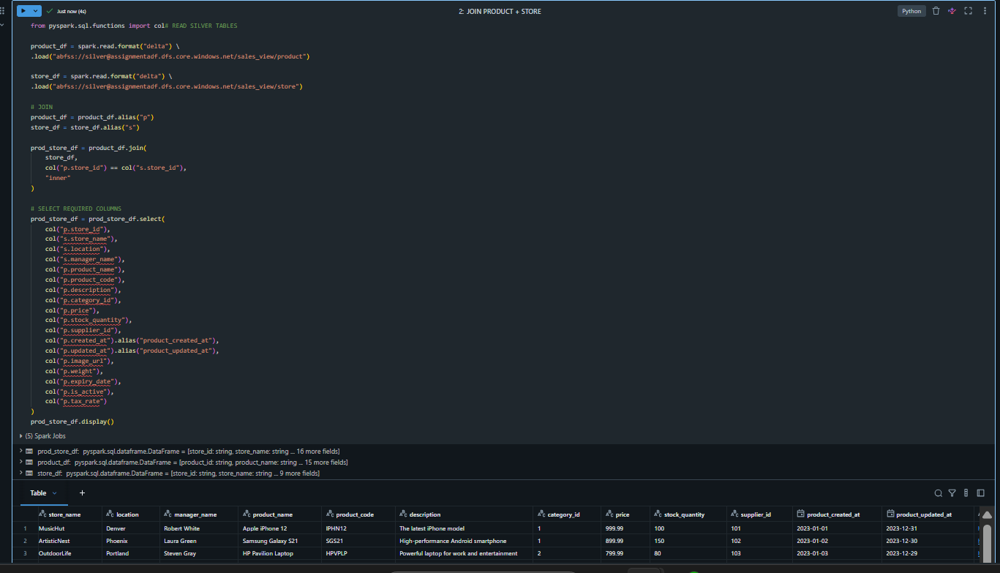

- Read the delta table (using UDF functions)
- Using the above data & customer_sales and get the below data
OrderDate,Category,City,CustomerID,OrderID,Product ID,Profit,Region,Sales,Segment,ShipDate,ShipMode,latitude,longitude,store_name,location,manager_name,product_name,price,stock_quantity,image_url
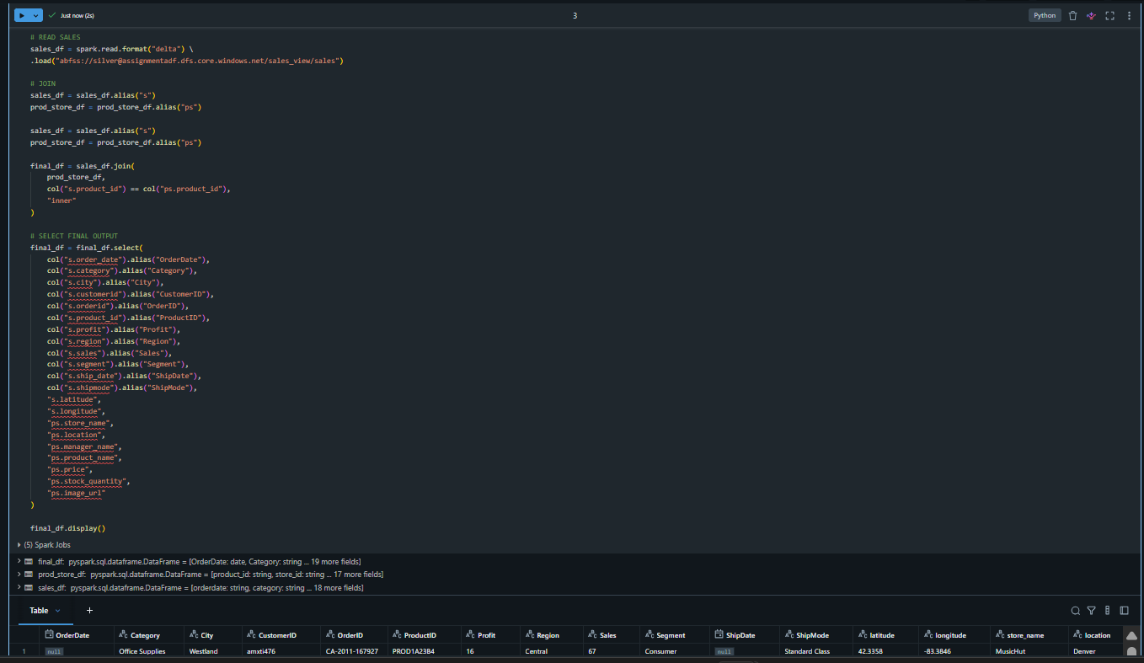
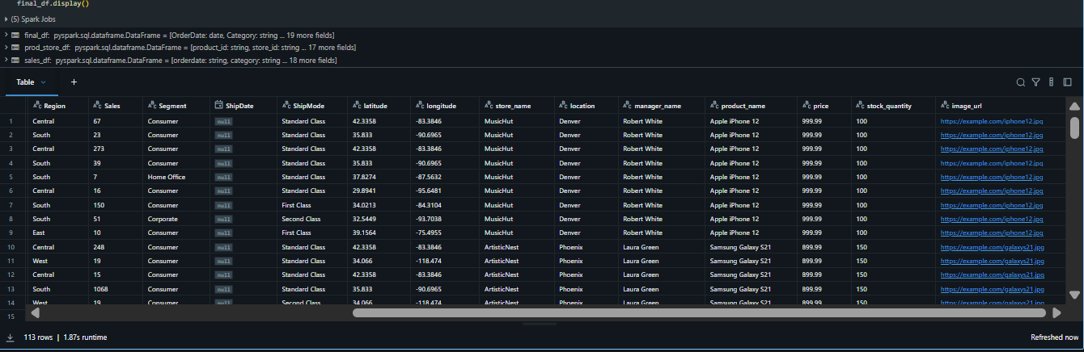
- Write based on overwrite (table_name : StoreProductSalesAnalysis )(in gold layer path is gold/sales_view/tablename/{delta pearquet}
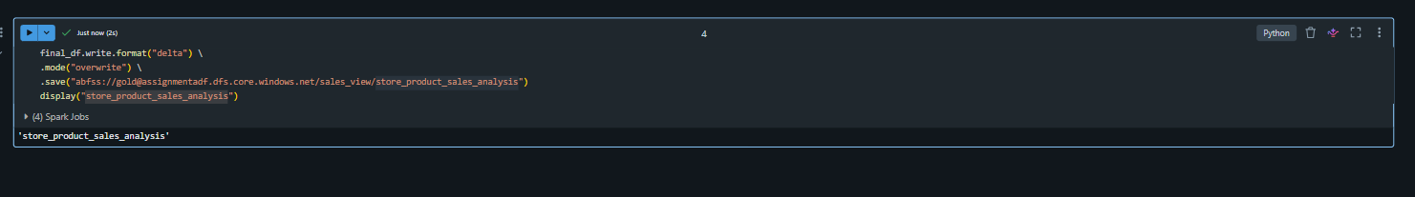
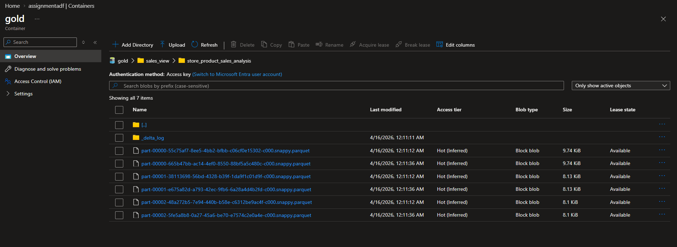
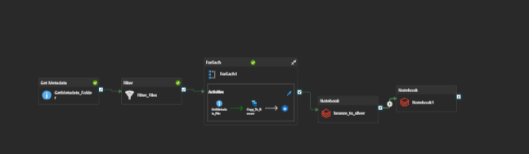
In ADLS
Paths: Are mentioned above
Bronze Layer (4 folder and raw files inside) Copied from ADF
1)customer
2)product
3)store
4)sales
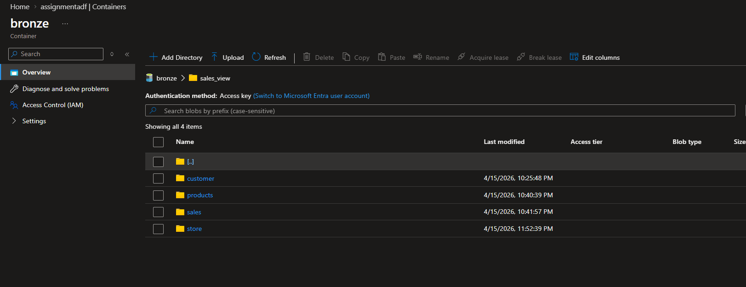
Silver Layer (4 folders with table name inside silver)
1)customer
2)product
3)store
4)customer_sales
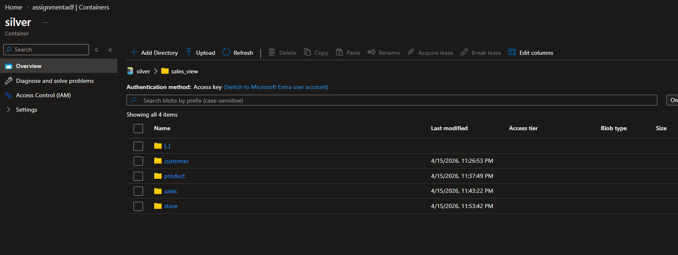
Gold Layer (1 folder with table name inside gold)
1)StoreProductSalesAnalysis


Question:
What is Data profiling and how it is done.
For the provided data what data profiling steps was done
Complete the above practical usecase given
Now write a usecase based on your understanding what is the architecture followed, completed understanding from end to end.

Assignment Summary:
We implemented a Medallion Architecture (Bronze → Silver → Gold) using Azure Data Factory and Azure Databricks to process and analyze sales data.

Bronze Layer (Raw Ingestion)
- Created ADLS containers and structured folders for customer, product, store, and sales data.
- Built an ADF pipeline using Get Metadata, Filter, and ForEach to dynamically identify and ingest the latest files.
- Copied raw data into the bronze layer without any transformation.
Path:
bronze/sales_view/{entity}/

Silver Layer (Data Cleaning and Transformation)
- Used Databricks (PySpark) to clean and standardize data.
- Converted column names to snake_case format.
- Handled inconsistent date formats and converted all dates to yyyy-MM-dd.
- Performed transformations such as:
  - Splitting name into first_name and last_name
  - Extracting domain from email
  - Mapping gender values (M/F)
  - Creating derived columns like expenditure_status
- Stored cleaned data as Delta tables.
Path:
silver/sales_view/{table_name}/

Gold Layer (Business-Level Aggregation)
- Joined product and store tables to create enriched product-store data.
- Joined this result with customer_sales data to produce a final analytical dataset.
- Selected only required business columns for reporting.
- Stored final output as a Delta table for analytics and reporting.
Path:
gold/sales_view/store_product_sales_analysis/

2. Data Profiling done for this dataset
For the given data, we performed:
- Checked column names and converted to snake_case
- Verified data types (many were string → converted properly)
- Handled date format issues (dd-MM-yyyy and MM-dd-yyyy)
- Checked and handled invalid numeric values (like spent, price)
- Verified columns like:
  - email_id → extracted domain
  - name → split into first and last name
- Ensured no schema mismatch before writing to Delta
- Validated joins using product_id and store_id

3.Practical Use Case Summary
We built a pipeline to process sales data from multiple sources daily.
- Data comes as CSV files (customer, product, store, sales)
- ADF pipeline picks the latest files automatically
- Raw data is stored in bronze layer
- Databricks cleans and transforms data into silver layer
- Finally, we join all data to create a business-ready dataset in gold layer

4. Architecture
We followed Medallion Architecture:
- Bronze Layer
Stores raw data as-is from ADF
- Silver Layer
Cleans data, fixes formats, creates new columns
- Gold Layer
Joins all data and creates final dataset for reporting

